SHRI RAMDEOBABA COLLEGE OF ENGINEERING AND MANAGEMENT, NAGPUR.



ECP455 Project Stage-1

(7TH SEM, SESSION 2022-2023)

**“Development of Point of Care Device for Measurement and Analysis of Vital Parameters”**

Submitted By

Group Number: 2

1. Parth Vishwas Bhalerao (Roll No.-65, Sec-A)
2. Huzefa Fakhruddin Essaji (Roll No.-41, Sec-B)
3. Vivek Kaushik (Roll No.-52, Sec-B)
4. Chandrakant Mohadikar (Roll No.-104, Sec-B)

Guide Name: Dr. Mridula Korde

Industry Guide: Mr. Anuj Sharma & Mr. Rahul Laddhad

Course Co-Ordinator: Prof. Ajinkya Nilawar

**Department of Electronics and Communication Engineering**

**Contents**

* **Introduction Pg No. 3**
* **Impact of Project on society and the environment Pg No. 4**
* **Block diagram and Functional description Pg No. 5**
* **Circuit diagram and its description Pg No. 8**
* **Working of Project Pg No. 10**
* **Code Implementation and Flowchart Pg No. 11**
* **Result and Future Scope Pg No. 12**
* **References/Citations Pg No. 16**

1. **Introduction**

As we know, whenever a patient goes to a doctor, with slightly irregular symptoms, the most common advice that is being given to him/her is to perform all vital related tests like ECG, blood test, PPG, Heart Rate, along with other parameters like body temperature, throat infection, eye checkup, as per the patient symptoms and requirements. It is necessary to get these tests done for the obvious reasons of early diagnosis of any disease.

As per a survey done in 2019, statistics show that over 25% to 50% of deaths worldwide are caused by cardiovascular diseases (CVD). An estimated 17.9 million people died due to CVD in the year 2019. In many such cases, either the disease was late diagnosed or was not even diagnosed till the death of the patient. However, this was the survey done before the Covid-19 pandemic and the cases of CVD have tremendously increased during and after the pandemic. This provides a necessity for such devices in the market and we must establish a complete end-to-end system right from collecting data from patients to consulting with a doctor. To provide a solution to this, we have designed a device with a low form factor and high portability providing functionalities like ECG monitoring, Heart Rate calculation and Body Temperature measurement.

Many times, people in rural areas do not have these facilities and they tend to migrate from rural areas to urban areas at several multi-specialty hospitals, to get these tests done but only a few of them manage to afford these expensive facilities. The Point of care Device will be able to deliver clinical outcomes at minimum cost as compared to standard medical test procedures. Also, it will be very safe and simple to use for the patients. This is a non-invasive type of device which will not cause any pain or discomfort to the patient and is hence more acceptable. Once the proof of concept is established on a limited set of human beings, this will lay the ground for clinical trials on a larger set of human beings. This will also be a requirement by the regulatory body.

An Accredited Social Health Activist is a community health worker employed by the Ministry of Health and Family Welfare as a part of India’s National Rural Health Mission. These health workers are called ASHA Workers. This Point of care device will be very helpful and handy to these ASHA workers to carry out health-related surveys in rural areas of India.

1. **Impact of the Project on society and the environment**

Using point-of-care devices will bring value to the following chain of users:

* **Patients:** With the onslaught of Covid, patients are increasingly being used to virtual consulting with their doctors. This has developed a sense of convenience to receive routine care to be sought as per their schedule, at their doorstep, using the Point of Care Diagnostic Device. Digital Health Option using this point-of-care device will provide an end to the expenses on the travel and logistics for the patients to get basic healthcare, thus reducing the pollution and load on the roads/rails.

The availability of Digital records provides patients with an alternative or a choice of taking a 2nd opinion from any other Specialist Doctor just by showing the test reports available. Preventive Diagnosis can lead to better planning and treatment of the patients before the advent of any major ailment.

* **Doctors:** With this POC Device at the patient's doorstep, the Doctors can easily evaluate the medical conditions of the Patients. Any routine corrective measure can be addressed on the spot. Thus, he can immediately provide relief to his patient situated remotely as well as increase the number of consultations done daily without any additional effort.

* **The Health Department GOI:** With the launch of the ambitious NDHM, it is pertinent to onboard the citizens for the Digital Health Card. Using this POC, not only can the citizens be registered but also their basic vital parameters can be recorded for future use.

Based on the digital medical data available, deficiency or any particular ailment in a specific region can be identified and corrective measures can be easily taken.

Using the POC Device, the cost of offering medical health services to Indian citizens can be significantly lowered as common diseases, and non-serious ailments can be easily addressed virtually by Senior Consultants from Government Hospitals.

So, based on the Test results delivered virtually by the POC Device to the Senior Doctors, an instant decision can be taken whether to shift the patient to a tertiary or main Government Hospital for immediate treatment. Thus, the quality of healthcare delivery services improves a lot, leading to prolonged lifespan and satisfied citizens in the upcountry.

1. **Block diagram and Functional description**

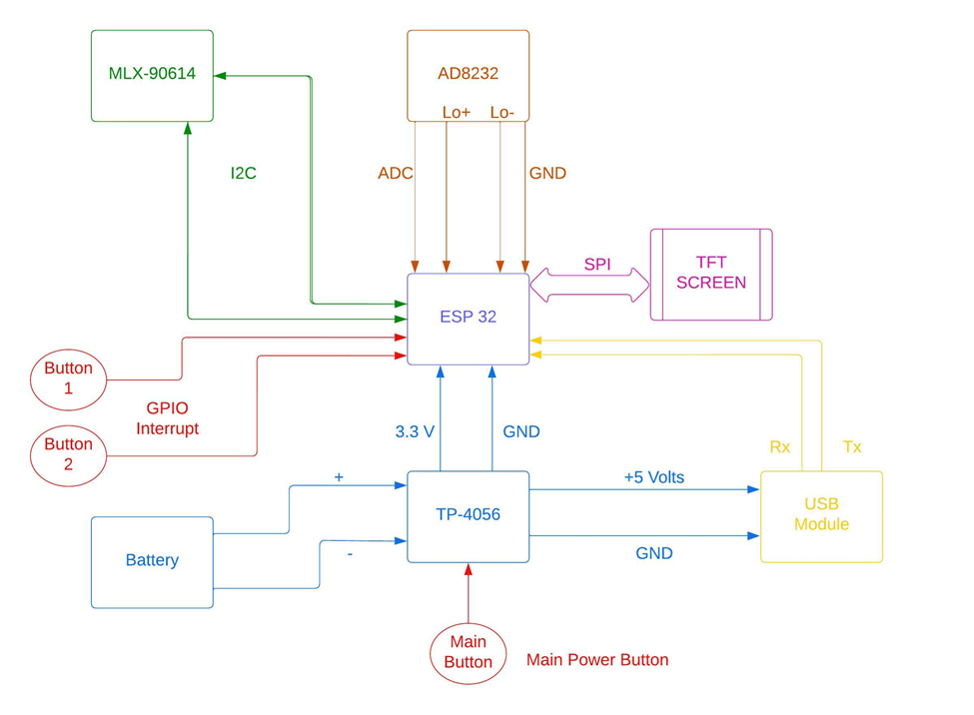

In this phase, we have developed a portable black box, which is able to perform two basic tasks, one is indicating the temperature of the body and the second is acquiring a 3-lead ECG and displaying it on a screen as well as calculating heart rate from it.

During the development of the prototype, we have majorly used the following components:

* ESP32: It is a SOC microcontroller with an integrated crystal of 40MHz, UART, SPI, PWM, ADC, DAC, and GPIO module interfaces, is equipped with internal ROM and SRAM, WIFI and Bluetooth and can be operated on 3.3V.
* TP4056: TP4056 module is a linear charger of lithium-ion batteries. This module can charge batteries consisting of single cells. Most importantly, it supports constant current and constant voltage modes of charging operations.
* AD8232 (ECG Sensor): AD8232 is an integrated signal conditioning block for ECG and other biopotential measurement applications. It is designed to extract, amplify, and filter small biopotential signals in the presence of noisy conditions, such as those created by motion or remote electrode placement.
* MLX-90614 (Temperature Sensor): The MLX90614 is a Contactless Infrared (IR) Digital Temperature Sensor that can be used to measure the temperature of a particular object ranging from -70° C to 382.2°C. The sensor uses IR rays to measure the temperature of the object without any physical contact and communicates to the microcontroller using the I2C protocol.
* TFT Screen (Display Screen): ILI9341 is a color display that uses SPI interface protocol and requires 4 or 5 control pins, it’s low cost and easy to use. The resolution of this TFT display is 240 x 320 which means it has 76800 pixels. This module works with 3.3V only and it doesn’t support 5V
* USB Module
* Battery and Push Buttons

The flowchart below shows the basic functional flow of our system

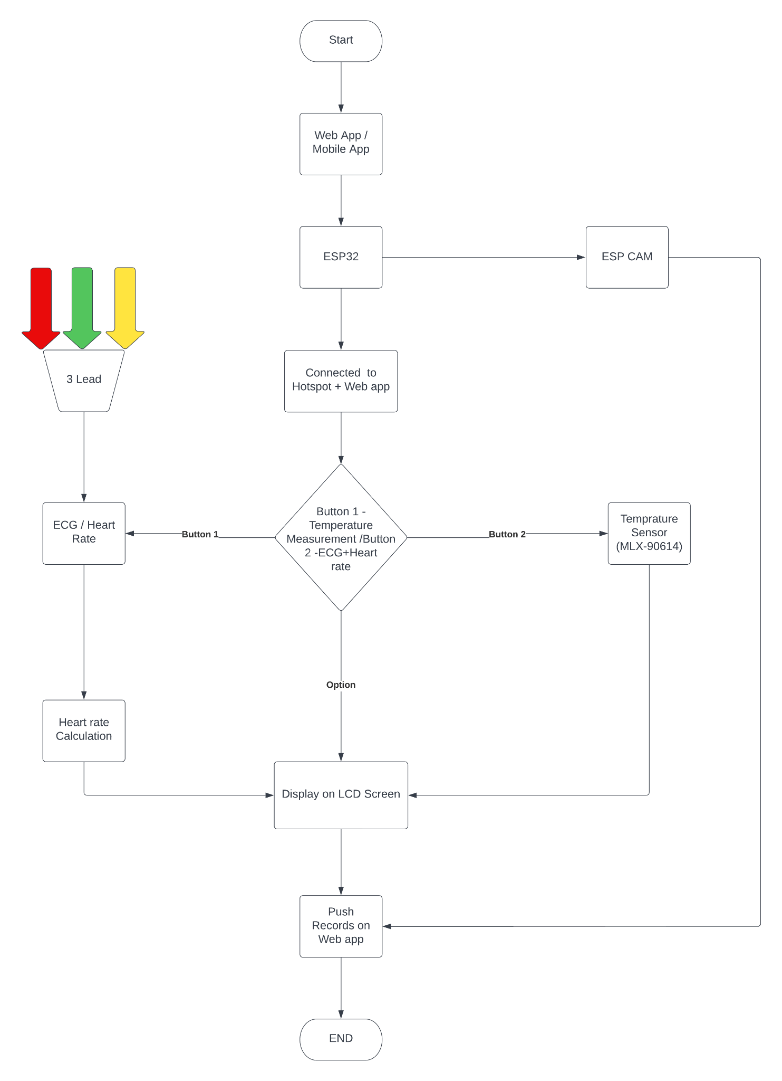

1. **Circuit diagram and its description**

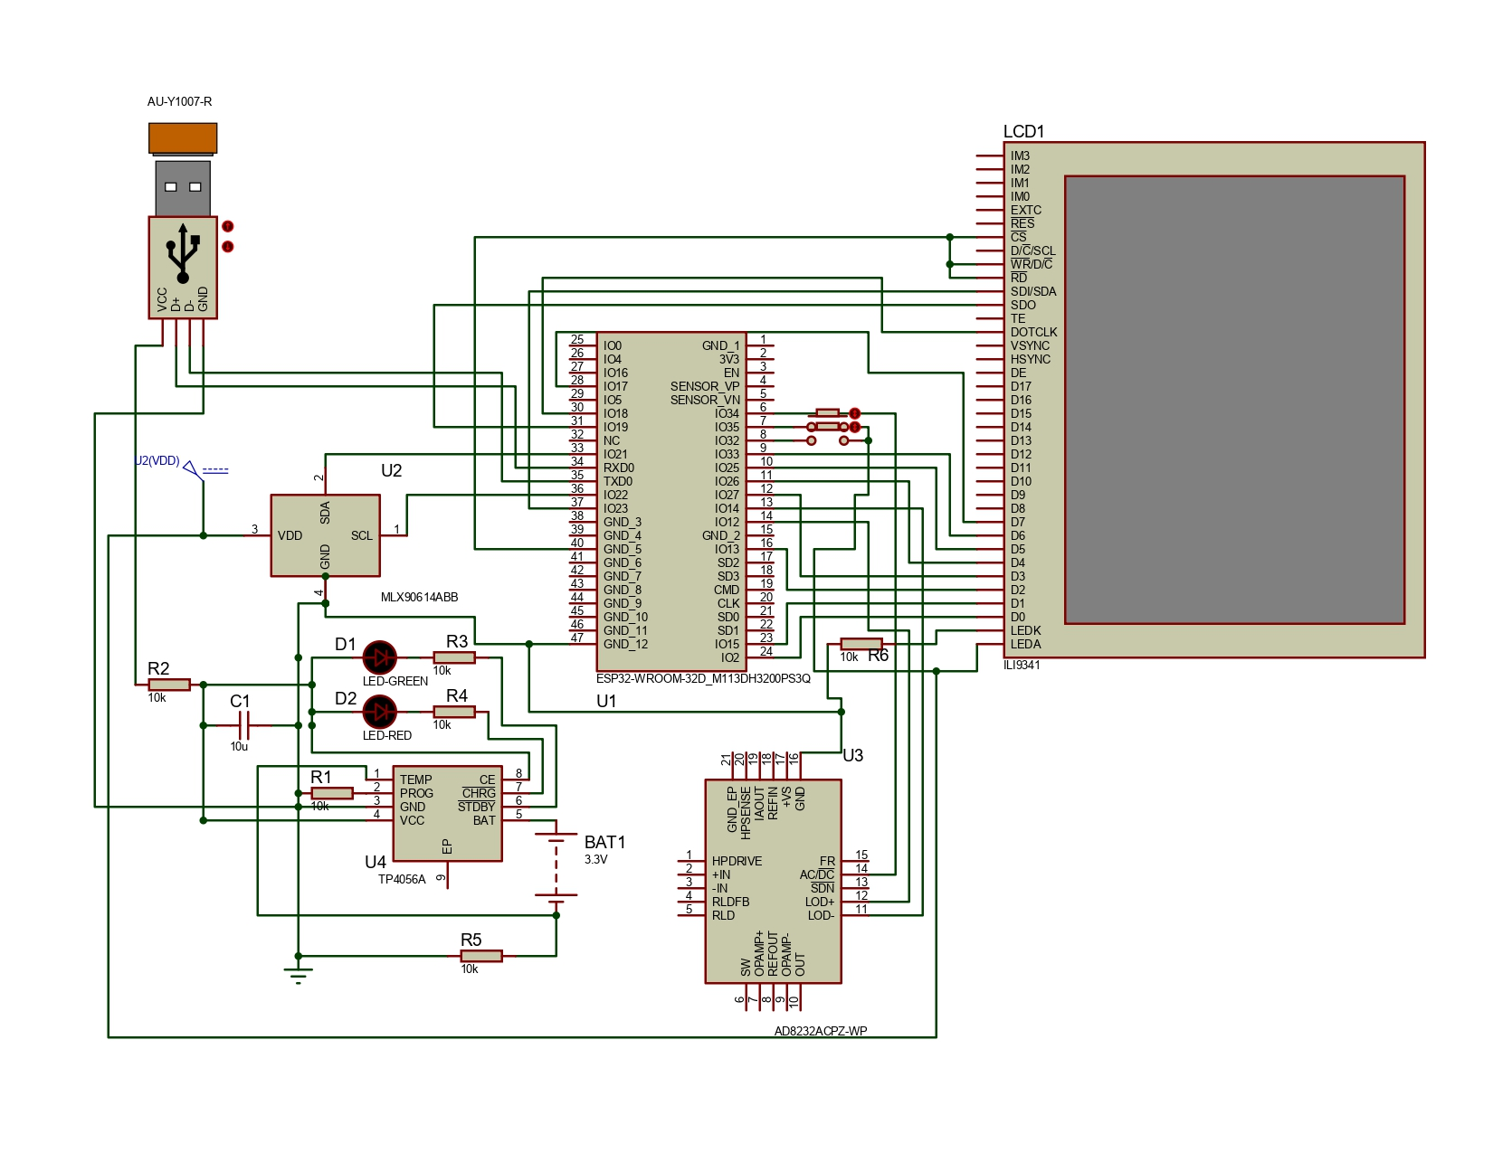

**Description:**

1. MLX90614 is the temperature sensor used, which will communicate with ESP32 via I2C Communication protocol (SDA, SCL). used to measure the contactless temperature.
2. TP4056 is a Power management IC that can be used to Charge the Battery through the USB Port. Battery used for this project will be 3.3Volt li-ion.
3. ILI9341 is the 2.4inch LCD module used, which will communicate with ESP32 via SPI Communication protocol (MOSI, MISO, CS, SCLK). It is used for displaying the data and waveform on LCD screen res.
4. AD8232 is an analog ECG module which is connected to the analog pin of the ESP32 controller also LO+ and LO- is used for lead detection.
5. There are two push buttons that are used to give user input.

**The proposed device has a following circuit components:**

|  |  |  |  |  |
| --- | --- | --- | --- | --- |
| Sr. no. | Component | Image | Pinout | Specifications |
| 1 | ESP32 |  |  | 40 MHz crystal  4MB SPI Flash  8MB PSRAM  2.3 – 3.6 Volts |
| 2 | MLX906104 temperature sensor |  |  | 3.5 Volts  -70oC – 380oC  0.5oC Accuracy  Works on I2C |
| 4 | TP4056 Charging Module |  |  | 4.5 – 5.5 Volts |
| 5 | AD8232 |  |  | 2 – 3.5 Volts  170 µA  ECG Sensor |
| 6 | ILI9314 |  |  | 173 Kbytes RAM  2.5 – 3.3 Volts |
| 7 | 3.3V Lithium-Ion Rechargeable Battery |  |  | 3.3 Volts |
| 8 | Switch |  |  | Push Button |

1. **Working of Project**

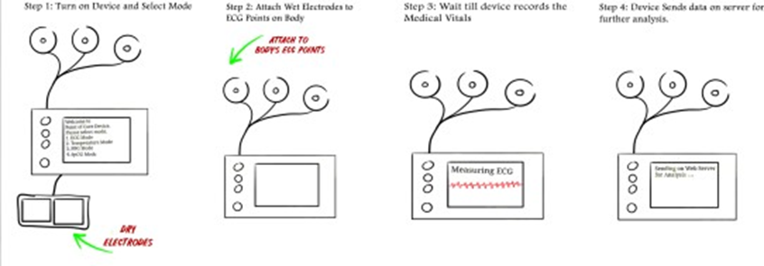

ESP32 communicates with temperature sensors via I2C protocol. Similarly, ESP32 is communicating with TFT Screen via SPI protocol. TP4056 is used as a power regulating IC, which is connected to a battery as a power source for the complete system as well as a USB Module. Push Buttons are used to give external interrupts. Three push buttons are used out of which, one is the power button to turn the device ON/OFF. The other two act as buttons for selecting options one is for temperature while the other is for selecting ECG and heart rate measurements.

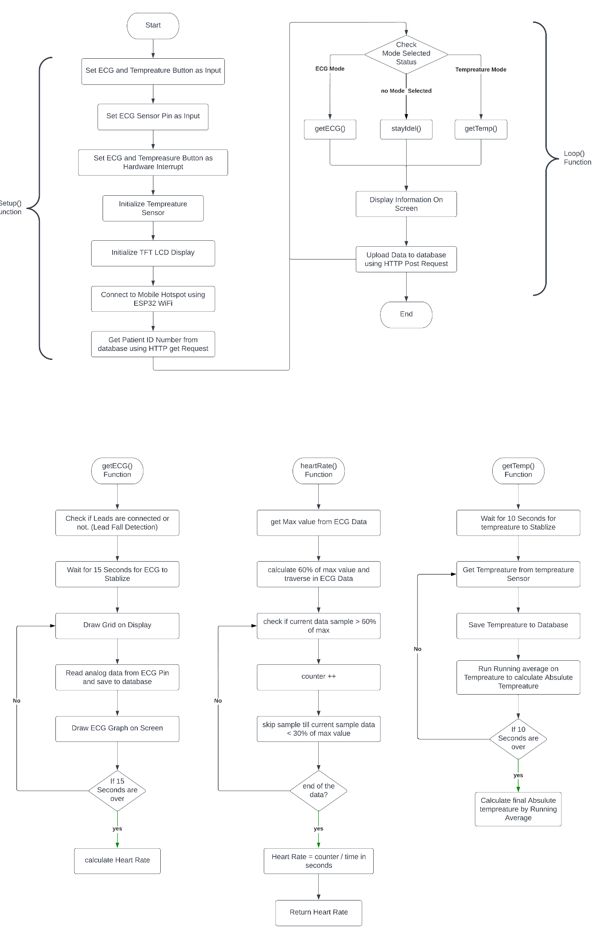

1. **Code Implementation**

The algorithm used to calculate heart rate from ECG can be explained as follows:

* Step-1

Record the ECG wave for a specific duration of time.

* Step-2

Get the value of maximum and minimum values that the waveform reached and calculate the difference between maximum and minimum values and obtain a threshold value.

* Step-3

Analyze the complete waveform and count the number of times the QRS complex crossed the calculated threshold value.

* Step-4

Consider the ECG wave is recorded for t-seconds and the count obtained from Step-3 is denoted by k.

Hence Heart rate in BPM can be calculated as: (k*60)/t

1. **Result and Future Scope**

The figure below shows the prototype device developed. The device is completely operational with proper established firmware.

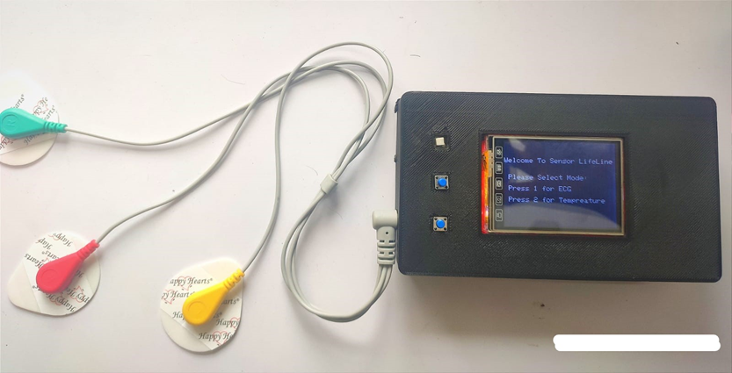

The figure given below shows how the ECG waveform is displayed on our screen. It can be observed that the obtained waveform consists of noise and needs further filtering. Similarly, figure below also shows how the data pushed from device is pushed to online web-server & web-app and waveforms can be observed along with calculated heart rate.

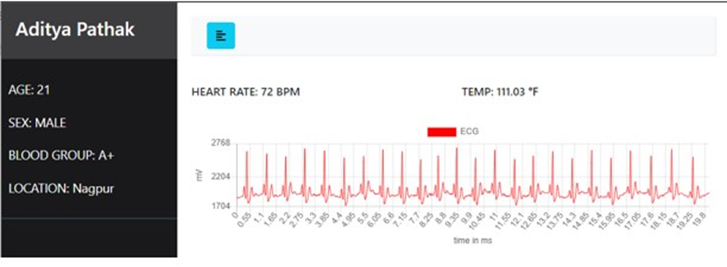

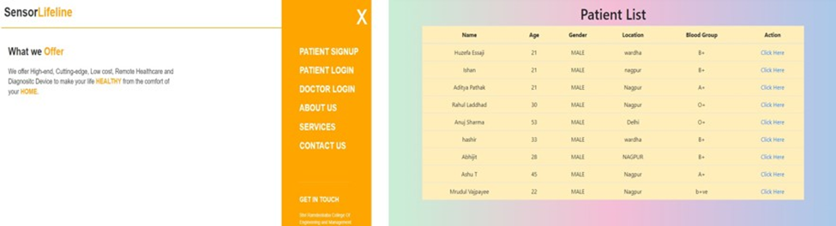

It has been observed that the above algorithm for calculating heart rate has more than 90% accuracy. However, it has been observed that algorithms produce errors in case the patient is not steady or still during recording of ECG. In such cases, the R-peak tends to rise abnormally and this leads to fluctuations in calculations of threshold value, further producing errors in heart rate. Hence, work has to be done on accuracy and improvement of heart rate calculation.

It can be observed from above figure that the acquired ECG wave is very noisy in nature and hence, filters must be applied on it in order to improve the quality of ECG wave obtained as this would be very necessary from a clinical point of view.

Several filters, particularly equipped for ECG noise filtering such as: Diagnostic, Ambulatory & Patient monitoring, ST segment, Muscle & ESU noise filters. However, out of these mentioned filters, Ambulatory & Patient monitoring would be most suitable in this scenario which has a frequency range of 0.67 to 40Hz acting as a band pass filter which is most suitable for mild filtering for noisy environments, principally to detect the heart rate. Hence, further work is required in designing such ambulatory filters.

The images below show the images taken from the camera module interfaced with our device and it can be observed that the throat passage, eye pupil and ear canal is clearly visible.

 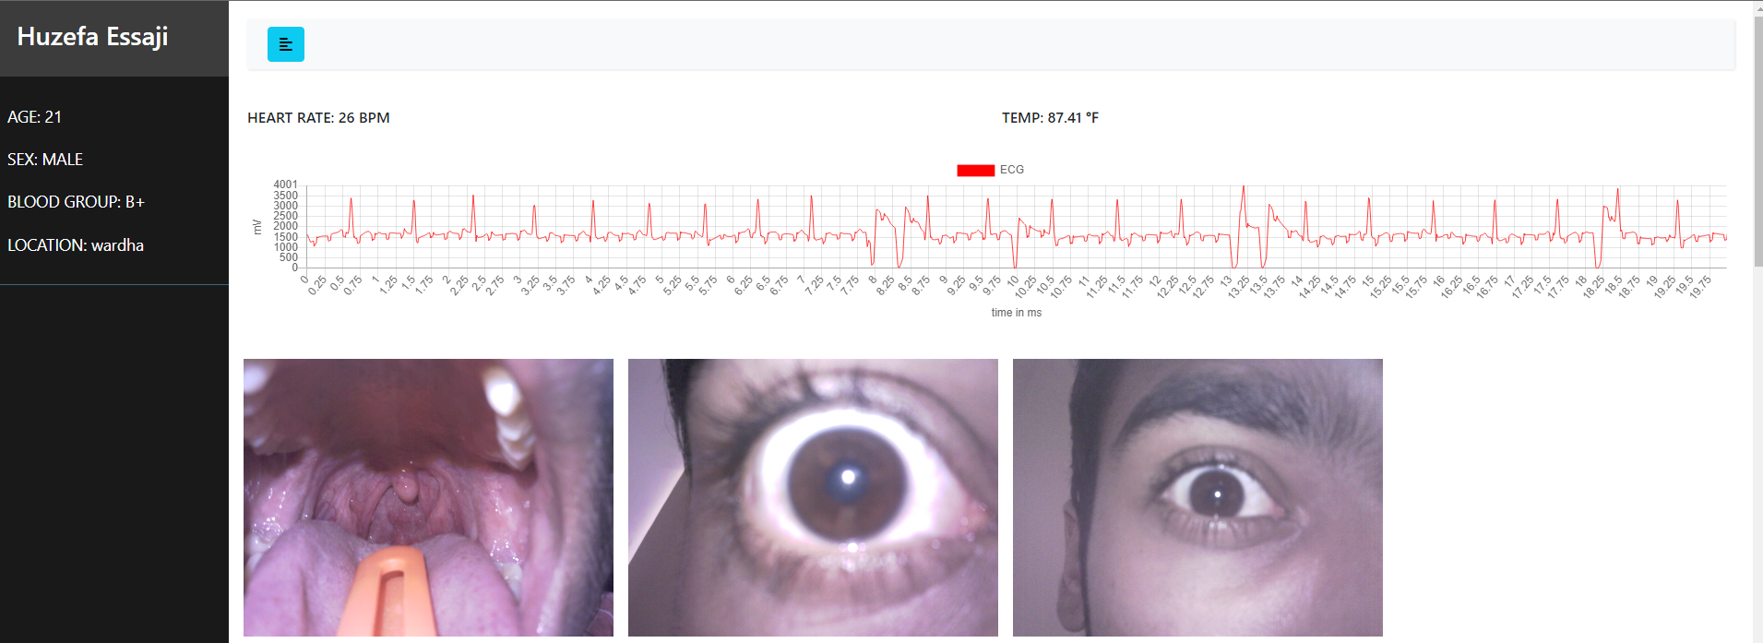

 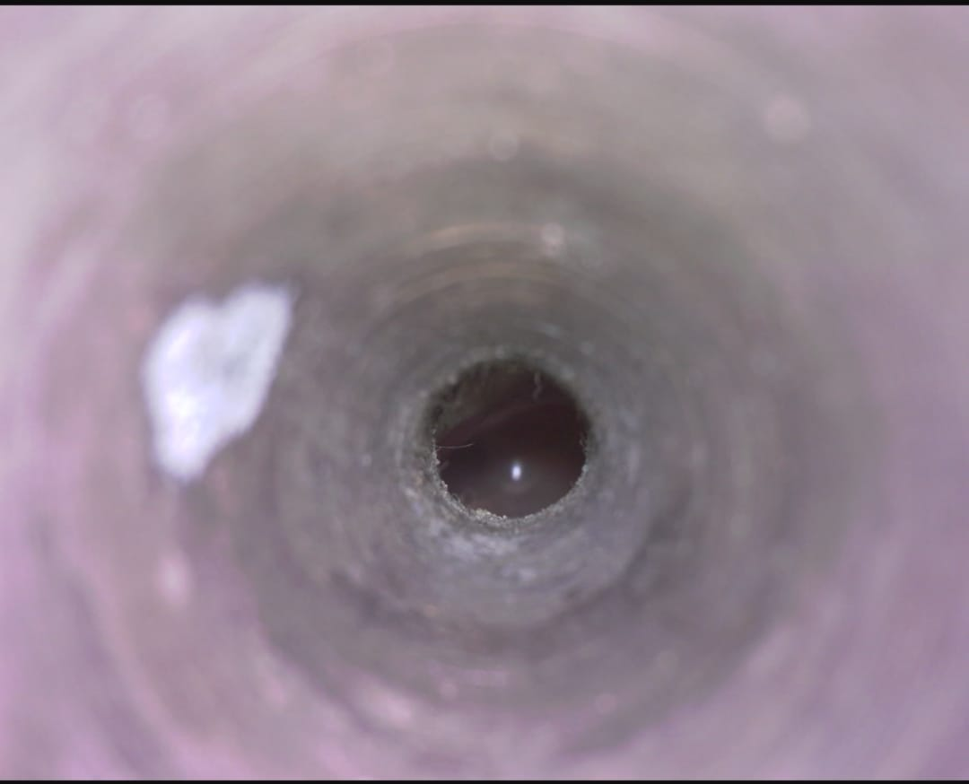

The prototype developed in this phase is sufficient enough to acquire ECG data and to display it. However, the system is not capable enough so that machine learning algorithms can be deployed in it. Also, in order to take this prototype to product stage and to put this for clinical trials or to sell to regular consumer, we need to improve the hardware and improve the credibility of the results. Also, the end product should have optimum power consumption. So, we must be able to deploy the machine learning model into our hardware for faster execution and edge computing. Similarly, we need to use medically graded sensors to improve accuracy and results.

Following is the list of components, which must be implemented as a part of phase-2 to make device capable of edge computing, faster analysis & clinical trials:

* STM32-F303RET6 (Microcontroller)
* MAX14745 (Power Management IC)
* MAX86178 Sensor (ECG & PPG Sensor with Analog Front End)
* MLX90614 Sensor (Temperature Sensor)
* HC08 (Bluetooth Module)

The idea and prototype mentioned above has room of improvement in several areas. Further study and work is needed to acquire ECG & PPG waveform from MAX86178 and perform its analysis as well. Also, further work is required on calculating Blood pressure from ECG & PPG data in a non-invasive way. Similarly, further work is required to find and train the best suitable model for ECG & PPG analysis and further deploy this model in STM32 for edge computing and faster analysis.

Along with this, several features can be added to this existing device such as, interfacing an additional camera module for taking images of retina and ear canal. Such a handy device would be easy for doctors to remotely monitor their patients by observing images of pupil or ear canal or any type of skin infections. As a result of this, a complete end to end ecosystem can be established for remote patient consultation and practo service. Further patient history could be linked to patients Aadhar card or Health card.

1. **References/Citations**

* Jourand, P., De Clercq, H., Corthout, R., & Puers, R. (2009). Textile integrated breathing and ECG monitoring system. Procedia Chemistry, 1(1), 722-725. Weiler, D. T., Villajuan, S. O., Edkins, L., Cleary, S., & Saleem, J. J. (2017, September).
* Wearable heart rate monitor technology accuracy in research: a comparative study between PPG and ECG technology. In Proceedings of the Human Factors and Ergonomics Society Annual Meeting (Vol. 61, No. 1, pp. 1292-1296).
* Chan, M., Estève, D., Fourniols, J. Y., Escriba, C., & Campo, E. (2012). Smart wearable systems: Current status and future challenges.
* Chung, H. U., Rwei, A. Y., Hourlier-Fargette, A., Xu, S., Lee, K., Dunne, E. C., ... & Rogers, J. A. (2020). Skin interfaced biosensors for advanced wireless physiological monitoring in neonatal and pediatric intensive-care units.
* Portable ECG Monitoring System with USB Host Interface (2010 IEEE-EMB), 2010 3rd International Conference on Biomedical Engineering and Informatics.
* Portable ECG Device for Remote Monitoring and Detection of Onset of Arrhythmia (IEEE 2020), 2020 IEEE International Conference on Electronics, Computing and Communication Technologies (CONECCT).
* A Survey: Classification of ECG Signals using Machine Learning Techniques (IEEE 2015), 2015 International Conference on Advances in Computer Engineering and Applications.
* Application of Machine Learning on ECG Signal Classification Using Morphological Features (IEEE 2020), 2020 IEEE Region 10 Symposium (TENSYMP).
* Estimation Of Blood Pressure by using Electrocardiogram (ECG) and Photo-plethysmogram (PPG) (IEEE 2015), 2015 Fifth International Conference on Communication Systems and Network Technologies.
* ECG Heartbeat Classification Using Multimodal Fusion (IEEE 2021), IEEE Access, 9, 100615–100626.